**A Cross-Curricular Project about Rock Music using Games Based Learning**

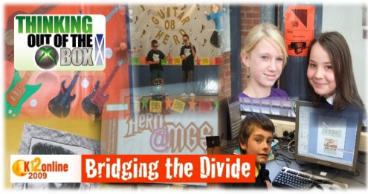

Orginally posted on [olliebray.com](http://www.olliebray.typepad.com)

The [2009 K-12 Conference](http://k12onlineconference.org/) has been as successful as ever and now its my turn to contribute to this years programme. My presentation ***'Using computer games to enhance learning and social interaction'*** goes live over on the K-12 site at 12.00h (GMT) today. This automated post provides a bit more background on the project that I describe and also gives a few more links.

Please feel free to leave any feedback below or over on the [K-12 Conference Ning](http://k12online.ning.com/). I’ll get back to you as soon as I can although I’m out and about a lot at the moment so it might not be straight away.

**Background and Introduction**

The project was inspired by some early work carried out in [Aberdeenshire](http://www.aberdeenshire.gov.uk/) by[Learning and Teaching Scotland’s](http://www.ltscotland.org.uk/) [Consolarium](http://www.ltscotland.org.uk/ictineducation/gamesbasedlearning/).  
   
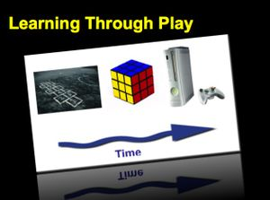

The idea behind the project is to use commercially available *‘off the shelf’*computer games that have been built for entertainment and then retrofitted for education. By their very definition commercially available games (due to their high production budgets) tend to be more engaging and cheaper than games that have been build solely for education. **The challenge is finding the right games that are suitable for use in the classroom.**

Another underlying principle of the project is that **in order for quality learning to take place there must be a combination good pedagogy** from the classroom teacher **combined with activities that are either interesting or engaging.** There is a distinct difference between what I mean by interest and engagement. Learning will quickly blossom if a child’s natural interest in a topic is combined with good teaching. Unfortunately many global education systems require children to have specific knowledge or specific skills that they find un-interesting. This is where teachers need to find engaging ways to deliver the content. **Technology including computer games can provide this engagement.**

For example the project described below has successfully used the game [Guitar Hero](http://hub.guitarhero.com/) as a stimulus to teach literacy, numeracy, art, physical exercise, science and lots of other curriculum areas.

This particular project was also designed to help children have a really positive end to primary school and a really positive start to secondary school during their time of transition. In Scotland (and in many other parts of the world) at transition the children move from having most of their teaching from a single teacher to a system of timetabling in the secondary school where they will be taught by perhaps 8 or 9 different teachers.  **It is widely recognised that transition and movement between primary to secondary school can be problematic for many pupils and can lead to conflict.** Appropriate computer games can provide the ideal medium to reduce conflict within schools at they are **competitive but in a non-threatening environment.**

***Further information about the project is below:***

**Thinking out of the xBox (Using Guitar Hero in Schools)**  
  
**Purpose**  
  
The purpose of the project was to improve the process of transition for pupils moving from primary (elementary) to secondary (high) school through the medium of a three stage innovative computer games based learning project.  
  
**Aims**

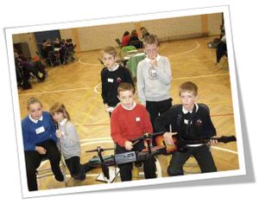

***The aims of the project were:***

* To improve the process of student transition between primary to secondary school.
* To develop relationships between cluster staff, students and parents.
* To use Guitar Hero as a context for learning within the seven Musselburgh primary schools during the summer term.
* To hold an innovative transition morning at the secondary school based around the game Guitar Hero.
* To use the theme Guitar Hero as a stimulus for discussion when the children moved to the secondary school.
* To develop a different way of updating primary teachers on individual student progress after they moved to the secondary school.
* To prove that school and learning can be fun!

**Structure of the project**  
  
***The learning for the project was structured in three main stages:***  
  
**Stage One –** Guitar Hero is used as a context for learning in primary seven (P7).  
  
This learning took place between the Easter holidays and the summer term 2008. Every primary school was given ownership of the project and a number of learning activities occurred. An example of the types of learning that took place are summarised below in this mind map from Stoneyhill Primary School. The mind map was created at the start of the project by the classroom teacher and their class.

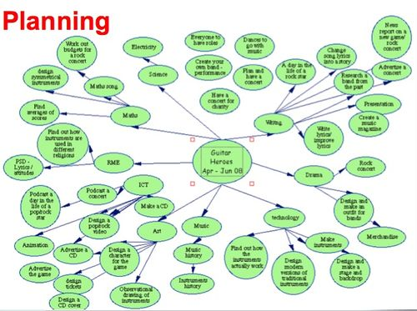  
As a result of this planning, a number of worthwhile activities took place across the cluster. Some of these activities [can be viewed in picture gallery](http://www.flickr.com/photos/olliebray/sets/72157605856155010/).  
  
     
**Stage Two -**All of the Primary 7 children visit the secondary school for a transition day to participate in a number of Guitar Hero related activities.   
  
The day was launched and concluded in the school assembly hall. During the day all of the children got to participate in three workshops using a *‘round robin’*rota system.  
  
**Workshop One -** The Battle of the Bands in the School Hall (1)  
  
There were 10 games consoles set up in the school hall. The children had to compete against someone who they had not met before. The collaboration during this activity was amazing. Senior students supervised the event so there was also an opportunity for new students to ask them questions about life at the school.

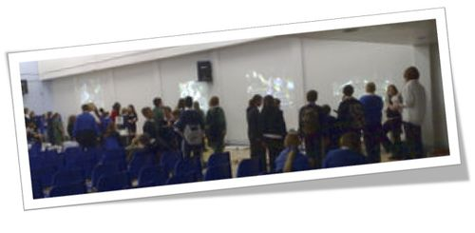

**Workshop Two -** The Guitar Hero Challenge

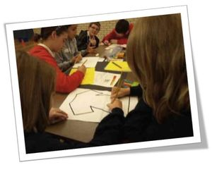

These workshops were facilitated by the school’s Guidance Staff. In Scotland secondary school guidance staff have the main pastoral / welfare responsibility for children.  
  
The first task was to ask the question, *‘tell me and your class what you have been learning about during the Guitar Hero Project’.* As each school took the project in its own direction, it was a chance for the class to communicate with each other about a common interest, swap ideas and learn about the learning in each others’ schools.  
  
The second task was to allow 20 minutes for the whole group to be split into smaller groups of 4/5 people and to come up with a band name, logo and jingle. One of the S6 students commented, *‘I can’t believe it, they have just come up with that in 5 minutes.’*  
  
Logos and jingles had to represent the interests of the whole team (eg: it was work about themselves). The finished products were photographed and videoed and the results were shown at the end of the morning.   
  
   
**Workshop Three –** Peer Led Activity

Each practical set, for the following year, had an opportunity to participate in a different activity. All of the activities had a different theme related to rock music or to the game. The idea behind this was to make the most of the senior pupil expertise from the secondary school, but also to capitalise on the peer led experience. The senior students were briefed to speak to the young children about the sorts of things that they might be embarrassed to ask adults. Things like where the toilets were, how much money to bring to the school, if they would be allowed out at lunchtime or not, etc...

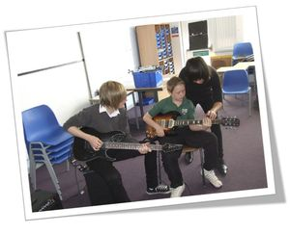

***The peer led activities included:***

* *Guitar Hero Orienteering –* using maps of the school to navigate around the school grounds to find the name of rock bands and answer the bonus Guitar Hero Questions.
* *Deigning a CD Case –*using Microsoft Publisher.
* *Designing a guitar –* using Photoshop
* *Rock Drama –* mime and improvisation to rock music in this workshop. It was great to see four different schools collaborating and working together in almost perfect sequence.
* *Rock Dance –*Led by S6 Student.
* *Meet the Band –*Working with an S6 band and learning how to play ‘Smoke on the Water’ on the guitar as well as getting a tour of the MGS recording studio.
* *iTunes Challenge –* A numeracy related quiz using Activote.

**Displays -** During the day there was also an opportunity for schools to display some of the Guitar Hero Work that they had produced over the last few months. It was all outstanding!  
  
  
**Stage Three –** Guitar Hero in the Secondary School

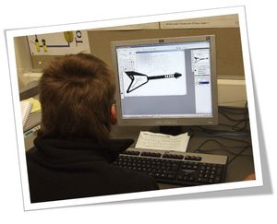

The final part of the project took place between the start of term and the October break 2008. The children were tasked with designing Guitar Hero Postcards and then sending them back to their old primary school teacher. The postcards were produced in CDT and the content was written in English.

Subject teachers were also tasked to use *‘Guitar Hero’* as a context for discussion with their new classes.  
This simple activity not only put closure on the project but was also a very powerful learning experience. It also developed increased communication between the primary and secondary school.

The quality of writing on the postcards was also outstanding as the children were writing with a real purpose. This was able to be used by the high school staff to provide formative feedback to students.

**Evolution of the Project**

**Local Scale**

The evaluation of the 2008 Guitar Hero Transition project was so positive that[East Lothian Council](http://www.eastlothian.gov.uk/) decided to copy the model and roll the project out across the education authority. During the summer term of 2009 all six clusters (that’s a total of 46 schools and over 70 xboxes in classes!) were involved in a new phase of the project based on the original Musselburgh model.

The Musselburgh Cluster staff were involved in training the new P7 teachers and working with each of the secondary schools to promote games based learning as a context for transition.

The project will continue in 2010 this time adding an international dimension to the work by networking xboxes. We hope this will provide an interesting way for children to learn about life in other countries, contribute to the breaking down of cultural difference and introduce an exciting way to learn about other topics such as time zones, location and place. Agian this new section of the project will have a strong literacy focus.  
  
**Wide Reach**

The [project blog](http://edubuzz.org/blogs/mgsguitarhero%20and%20www.olliebray.com) have been successful that now other schools elsewhere in Scotland, UK and internationally have started to mirror the project and adapt it for local need. An [additional project website](http://sites.google.com/a/edubuzz.org/guitarhero09/Home) was set up to support the larger 2009 project and web stats for both sites show that lesson material has been downloaded all over the UK and a number of other countries including the  USA, Australia, Sri Lanka and Hong Kong.  
  
**Awards and Recognition**

*The project has won a number of awards including:*

* Winner Microsoft UK Innovative Teacher Forum *- Feb 2009*
* 1st Place Microsoft European Innovative Teacher Forum (Innovation in the Community) *- April 2009*
* 2nd Place Microsoft Worldwide Innovative Teacher Forum (Innovation in the Community) *- November 2009*

***If you have further information about the project then please get in touch with Ollie Bray –*** [***olliebray@gmail.com***](mailto:olliebray@gmail.com)